**Imposter Syndrome**

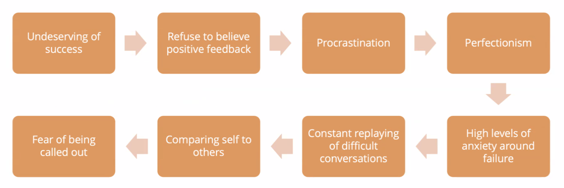

In orer to reframe your thoughts you need to write it down

What would I tell my best friend in this situation

Example of a time I struggled

Assesment center- interview to get on the course.

Comparing with others, they might be selected (because they know other languages that you might not know) and I might not.

They’ll realise Im not up to the level they thought I was.

Partially true- you might not know stuff,

Your tell yourself that

You did the same interview as tohers if you proceed they chose you for a reason,youll have to learn things a the basic level as everyone else